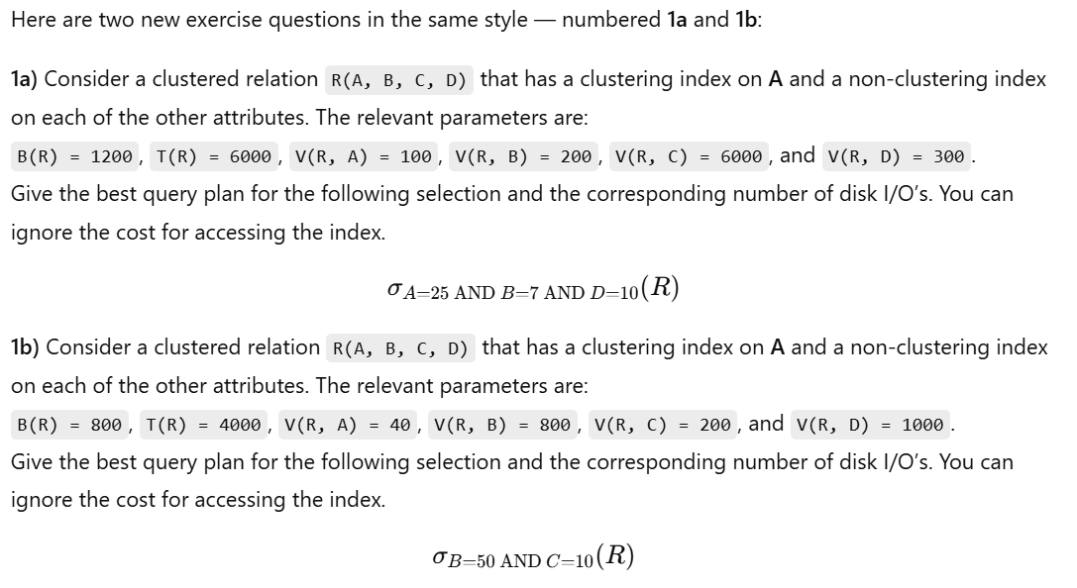

🔹 Selection: Example (2)
Selection:
σ_{A>50 ∧ B=10 ∧ C≤200}(R)
T(R) = 20,000
B(R) = 800
V(R, A) = 1000
V(R, B) = 200
V(R, C) = 400
R is unclustered.
There are indexes on attributes A, B, and C,
but only the index on B is clustering.

🔹 Selection: Example (3)
Selection:
σ_{Dept='Sales' ∧ Salary>50000 ∧ Age<30}(Employee)
T(Employee) = 50,000
B(Employee) = 2000
V(Employee, Dept) = 20
V(Employee, Salary) = 10,000
V(Employee, Age) = 40
Relation is clustered on Salary.
There are secondary (non-clustering) indexes on Dept and Age.
Only Salary has a clustering index.

here’s a clear, step-by-step “what’s going on” behind that solution, plus a tiny concrete example so it clicks.

1) The setup: what the symbols mean
- R(A,B,C,D) is a heap file laid out on disk in data pages (blocks).
- B(R)=1000 → the table occupies 1000 data pages.
- T(R)=5000 → 5000 tuples total → on average 5 tuples/page.
- V(R,X) = number of distinct values of attribute X in R. It’s used for uniform-selectivity estimates:
  - For an equality X = c, expected fraction of rows ≈ 1 / V(R,X).
  - Expected matching tuples = T(R) / V(R,X).
- Clustering index on A: rows with the same A are physically near each other on disk (so an equality on A touches a contiguous run of pages).
- Non-clustering (secondary) index on B, C, D: the index points to rows, but the rows are scattered across pages (so fetching many matches means many random page reads).
In this exercise we’re told: ignore index-access cost (the few I/Os to traverse the index tree). Only count data-page I/Os.

2) How to estimate I/Os for each access path

a) Full scan
Read every page once → B(R) = 1000 I/Os.

b) Equality using a clustering index (here: A = 10)

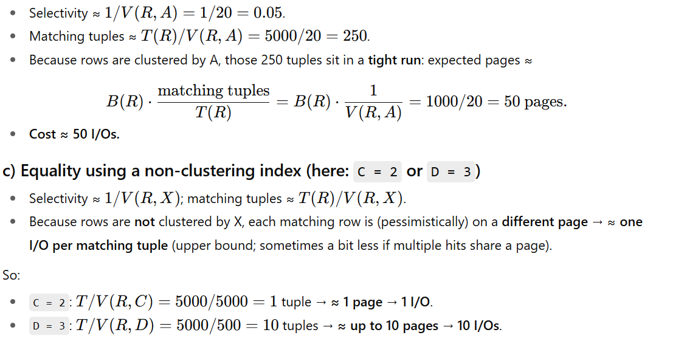

3) Which path is best for σ_{A=10 AND C=2 AND D=3}(R)?
SQL AND means all three predicates must hold, but most engines choose exactly one index to fetch candidate rows, then apply the other predicates in memory (unless they support bitmap/index-ANDing).
Compare the costs we just estimated:
- Full scan: 1000 I/Os
- Via A=10 (clustered): 50 I/Os
- Via C=2 (non-clustered): 1 I/O
- Via D=3 (non-clustered): 10 I/Os
Best starting point is C = 2 (cheapest). We fetch those tuple(s) and then check A=10 and D=3 in memory.
Answer: use the index on C → ~1 I/O.
Why not start with A=10? Because even though clustered access is efficient, it still pulls ~50 pages, whereas C=2 pulls ~1 page. Ultra-selective beats clustered here.

4) Tiny concrete example (to make it tangible)
Imagine pages P1 … P1000, each with 5 rows.
- Because of clustering on A, all rows with A=10 live contiguously on ~50 pages (say P301 … P350).
- The single row with C=2 sits (by chance) on page P742. There’s a non-clustered index on C that tells us “go to P742”.
- The 10 rows with D=3 might be on P50, P117, P326, … scattered around.
Plans:
- Scan: read P1 … P1000 → 1000 I/Os.
- Use A=10: jump to P301 … P350 (contiguous) → ~50 I/Os, then filter on C and D.
- Use C=2: jump to P742 only → 1 I/O, then check if that row’s A=10 and D=3.
- Use D=3: jump to ~10 disparate pages → ~10 I/Os, then check A and C.

5) What about combining indexes?
Some systems can intersect secondary indexes (bitmap AND). If you AND the posting lists for C=2 and D=3, you’d likely still get ≤ 1 row here. But even then, you must fetch the data page(s) for the intersection. In our simple cost model (ignoring index-traversal), this is no better than just using the most selective index (C=2).
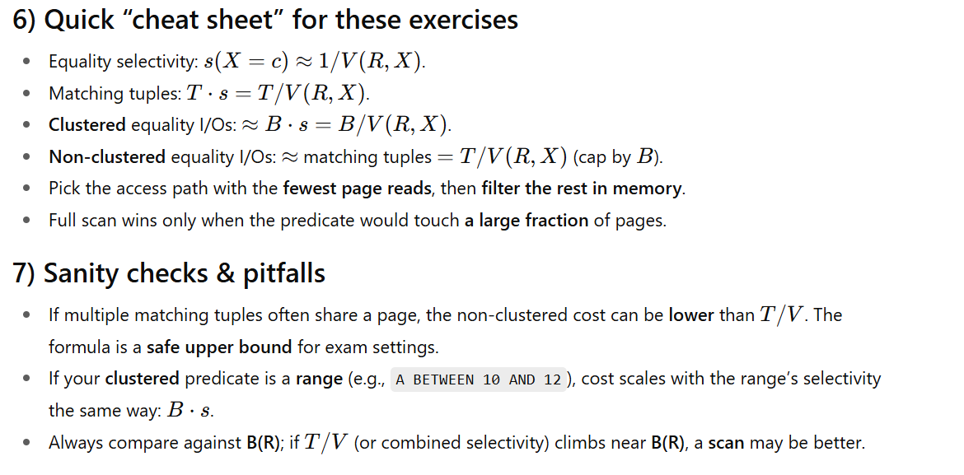

query optimization and index usage in DBMS with cost calculation based on given parameters.

1️⃣ Question: Multi-Attribute Selection
Consider a clustered relation S(E, F, G, H) with:
- Clustering index on E
- Non-clustering indexes on F and H
- Parameters:
  - B(S) = 2000 (number of blocks)
  - T(S) = 10,000 (number of tuples)
  - V(S, E) = 50, V(S, F) = 1000, V(S, G) = 10,000, V(S, H) = 500
Find the best query plan and the I/O cost for:
σE=25 AND F=100(S)

2️⃣ Question: Range Selection
A relation T(X, Y, Z) has:
- Clustering index on X
- Non-clustering index on Y
- Parameters:
  - B(T) = 1500
  - T(T) = 30,000
  - V(T, X) = 100
  - V(T, Y) = 3000
  - V(T, Z) = 500
Determine the optimal plan and disk I/O cost for:
σX ≥ 50 AND Y=1200(T)

3️⃣ Question: Join with Index
Relation U(M, N, O) is clustered on M, and relation V(P, Q, R) is clustered on P.
- B(U) = 1200, T(U) = 24,000, V(U, M) = 80
- B(V) = 1800, T(V) = 36,000, V(V, P) = 120
Find the best join method and I/O cost for:
U ⋈U.M=V.P V

4️⃣ Question: Combined Predicate
Given a relation W(A, B, C, D):
- Clustering index on A
- Non-clustering indexes on B and C
- Parameters:
  - B(W) = 500
  - T(W) = 20,000
  - V(W, A) = 200, V(W, B) = 1000, V(W, C) = 2000, V(W, D) = 500
Evaluate:
σA=50 AND B≥200 AND C=1000(W)
Provide the query plan and I/O estimation.

5️⃣ Question: Selectivity Calculation
For a relation R1(A, B) with:
- B(R1) = 800, T(R1) = 40,000
- V(R1, A) = 400, V(R1, B) = 800
Estimate the selectivity and disk I/O cost for:
σA=10 OR B=20(R1)

here are the full, step-by-step solutions for Q3 (join) and Q4 (selection).
